TALENT LINK
NAME: SAKTHIPRIYA S
BATCH NO: 1

1.WEEK -1:
1. Define scope and user roles: Client, Freelancer.
2. Design database schema (users, profiles, projects, proposals, contracts, messages, reviews, skills).
3. Initialize Django project with Django REST Framework

1.SCOPE:
Build a marketplace connecting Clients and Freelancers where Clients post projects, Freelancers submit proposals, a contract can be created from an accepted proposal, and both sides can message and review. Secure auth, role-based access, and REST APIs for a React frontend.

USER ROLES:
Client
- Can create/edit/delete projects
- View proposals made to their projects
- Accept/reject proposals → create contracts
- Message freelancers about projects
- Leave reviews after project completion
Freelancer
- Create/edit profile with portfolio & skills
- Browse/search projects
- Submit proposals to projects
- Negotiate via messages
- Sign/accept contracts and get reviewed

DATABASE TABLES:
USERS TABLE:
Field | Type | Description
user_id (PK) | int | Unique ID
name | string | Full name
email | string | Login email
password | string | Encrypted password
role | string | ‘client’ or ‘freelancer’
date_joined | datetime | User creation date

PROFILES TABLE:
Field | Type | Description
profile_id (PK) | int | Unique
user_id (FK) | int → Users | Linked to user
bio | text | About the user
hourly_rate | decimal | Freelancer rate
location | string | City/Country
avatar | string | Profile photo path

SKILLS TABLE:
Field | Type | Description
skill_id (PK) | int | Unique ID
skill_name | string | e.g. Python, React

Profiles ↔ Skills = Many-to-Many relationship
This needs a mapping table:

PROFILE_SKILLS TABLE
profile_id (FK) | skill_id (FK)

PROJECTS TABLE
Field | Type
project_id (PK) | int
client_id (FK) | int → Users
title | string
description | text
budget_min | decimal
budget_max | decimal
status | string (‘open’, ‘closed’)
created_at | datetime

Projects ↔ Skills = Many-to-Many
Mapping table:
PROJECT_SKILLS TABLE
| project_id (FK) | skill_id (FK) |

PROPOSALS TABLE:
Field | Type
proposal_id (PK) | int
project_id (FK) | int
freelancer_id (FK) | int
cover_letter | text
proposed_budget | decimal
proposed_duration | int (days)
status | string (pending/accepted/rejected)
created_at | datetime

CONTRACTS TABLE:
Field | Type
contract_id (PK) | int
proposal_id (FK) | int
project_id (FK) | int
client_signed | bool
freelancer_signed | bool
status | string (active/completed)
start_date | date
end_date | date

MESSAGES TABLE:
Field | Type
message_id (PK) | int
sender_id (FK) | int
receiver_id (FK) | int
project_id (FK, optional) | int
contract_id (FK, optional) | int
content | text
timestamp | datetime
is_read | boolean

REVIEWS TABLE:
Field | Type
review_id (PK) | int
contract_id (FK) | int
reviewer_id (FK) | int
reviewee_id (FK) | int
rating | int (1–5)
comment | text
created_at | datetime

DIAGRAM:
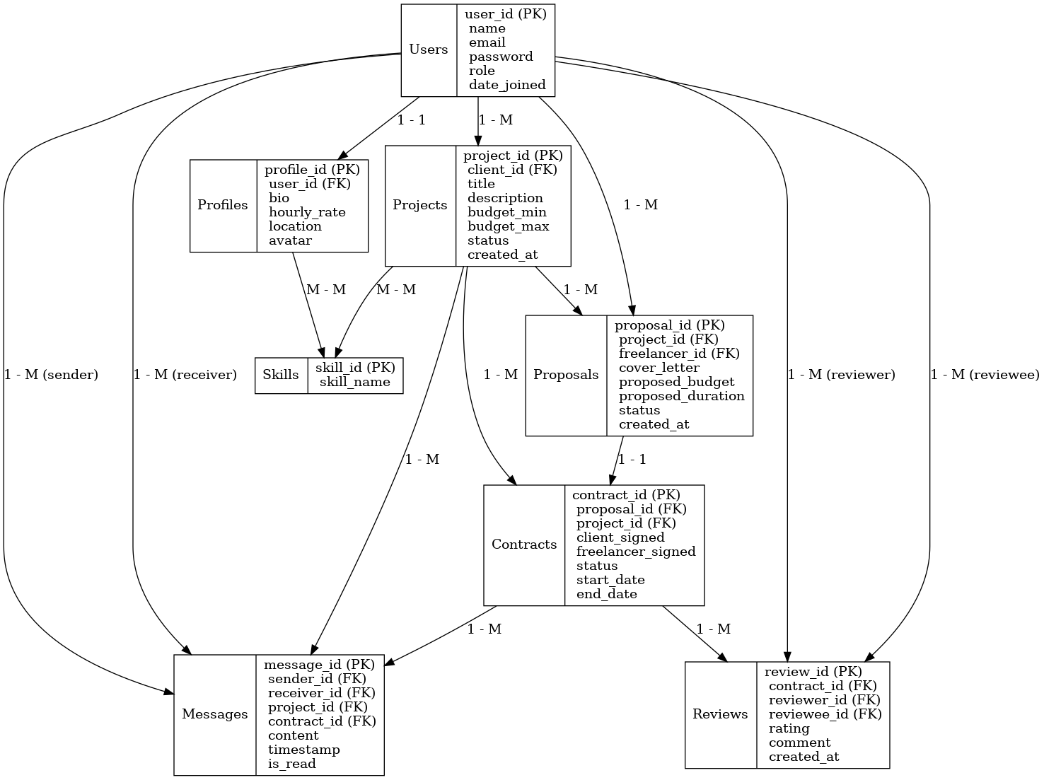
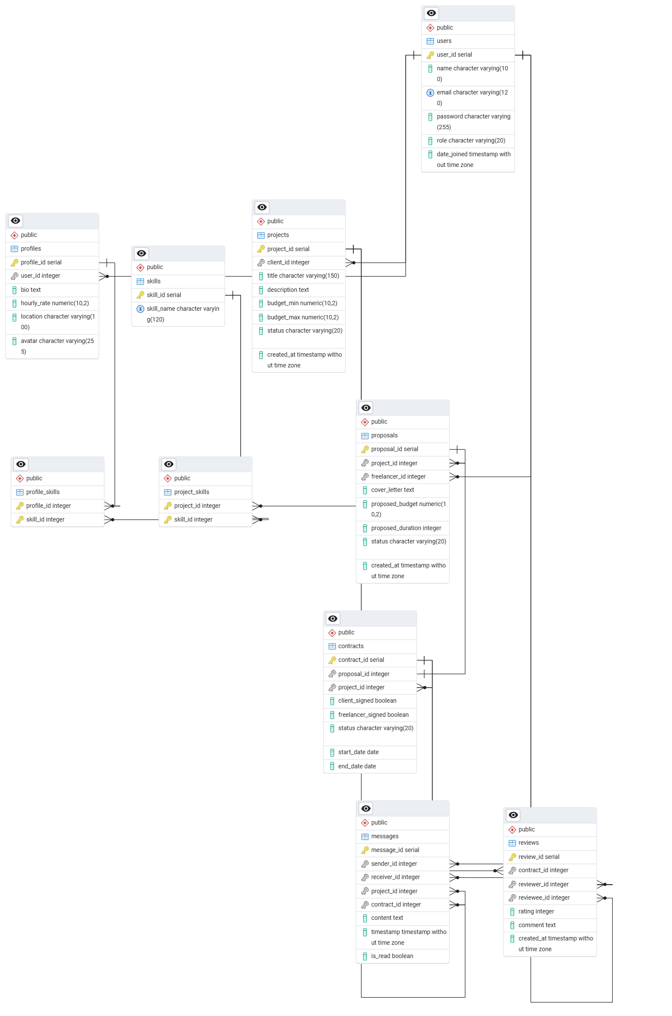
DJANGO ADMIN PAGE
